

Giftcon Service with Galaxia-MoneyTree

**Development Plan**

내용

1. Plan history 2

2. Policy Definitions 3

3. Requirements Definitions (Functions Definitions) 4

4. Tables Definitions 4

4.1 CouponSetup 4

4.2 ProductList 5

4.3 CouponIssue 6

4.4 CouponHistory 6

4.5 KFTC_DOMESTIC_HISTORY 7

5. Sequence Diagram 8

6. UI Design 9

6.1 Reward 포인트 구매 리스트 9

6.2 거래내역조회 화면 10

# Plan history

|  |  |  |  |  |
| --- | --- | --- | --- | --- |
| Version | Date | Author | Type | Contents |
| 1.0 | 2020.11.30 | Max | 초안 | Giftcon Service with Galaxia-MoneyTree |
|  |  |  |  |  |
|  |  |  |  |  |
|  |  |  |  |  |
|  |  |  |  |  |
|  |  |  |  |  |
|  |  |  |  |  |

# 2. Policy Definitions

|  |  |  |
| --- | --- | --- |
| ID | Policy Name | Policy Contents |
| POLICY-001 | 상품권의 유효기간 | 발행일로부터 5년?? |
|  | 정산금액 | 정산금액= 상품대금 – 판매수수료 |
|  |  |  |
|  |  |  |
|  |  |  |
|  |  |  |
|  |  |  |

# 3. Requirements Definitions (Functions Definitions)

|  |  |  |
| --- | --- | --- |
| ID | Requirement Title | Requirement Contents |
| REQ-001 | 편의점 상품권의 종류 | CU, GS25, 세븐일레븐   * 3천원, 5천원, 1만원, 2만원 |
| REQ-002 |  |  |
| REQ-003 |  |  |
| REQ-004 |  |  |
| REQ-005 |  |  |
| REQ-006 |  |  |
| REQ-007 |  |  |
|  |  |  |
|  |  |  |
|  |  |  |
|  |  |  |
|  |  |  |
|  |  |  |

# 4. Tables Definitions

## 4.1 CouponSetup

|  |  |  |  |  |
| --- | --- | --- | --- | --- |
| Column Name | Type(Length) | Key | Required | Description |
| rowId | bigint | PK | Y |  |
|  |  |  |  |  |
|  |  |  |  |  |
|  |  |  |  |  |
|  |  |  |  |  |
|  |  |  |  |  |
|  |  |  |  |  |
|  |  |  |  |  |
|  |  |  |  |  |
|  |  |  |  |  |
|  |  |  |  |  |
|  |  |  |  |  |
|  |  |  |  |  |

## 4.2 ProductList

|  |  |  |  |  |
| --- | --- | --- | --- | --- |
| Column Name | Type(Length) | Key | Required | Description |
| rowId | bigint | PK | Y |  |
|  |  |  |  |  |
|  |  |  |  |  |
|  |  |  |  |  |
|  |  |  |  |  |
|  |  |  |  |  |
|  |  |  |  |  |
|  |  |  |  |  |
|  |  |  |  |  |
|  |  |  |  |  |
|  |  |  |  |  |
|  |  |  |  |  |
|  |  |  |  |  |
|  |  |  |  |  |
|  |  |  |  |  |

## 4.3 CouponIssue

|  |  |  |  |  |
| --- | --- | --- | --- | --- |
| Column Name | Type(Length) | Key | Required | Description |
| rowId | bigint | PK | Y |  |
|  |  |  |  |  |
|  |  |  |  |  |
|  |  |  |  |  |
|  |  |  |  |  |
|  |  |  |  |  |
|  |  |  |  |  |
|  |  |  |  |  |
|  |  |  |  |  |
|  |  |  |  |  |
|  |  |  |  |  |
|  |  |  |  |  |

## 4.4 CouponHistory

|  |  |  |  |  |
| --- | --- | --- | --- | --- |
| Column Name | Type(Length) | Key | Required | Description |
| rowId | bigint | PK | Y |  |
|  |  |  |  |  |
|  |  |  |  |  |
|  |  |  |  |  |
|  |  |  |  |  |
|  |  |  |  |  |
|  |  |  |  |  |
|  |  |  |  |  |
|  |  |  |  |  |
|  |  |  |  |  |

## 4.5 KFTC_DOMESTIC_HISTORY

|  |  |  |  |  |
| --- | --- | --- | --- | --- |
| Column Name | Type(Length) | Key | Required | Description |
| rowId | bigint | PK | Y |  |
|  |  |  |  |  |
|  |  |  |  |  |
|  |  |  |  |  |
|  |  |  |  |  |
|  |  |  |  |  |
|  |  |  |  |  |
|  |  |  |  |  |
|  |  |  |  |  |
|  |  |  |  |  |

# 5. Sequence Diagram

# 6. UI Design

## 6.1 Reward 포인트 구매 리스트

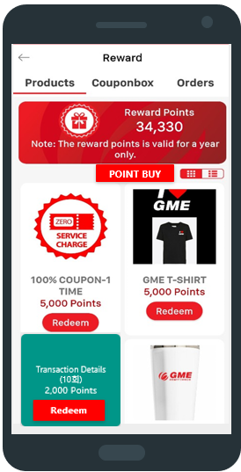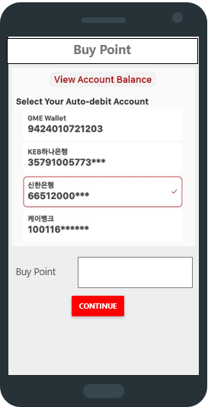

## 6.2 거래내역조회 화면

